**Initial Data Analysis**

***Marzena Porebski***

***December 4, 2019***

**Load Data**

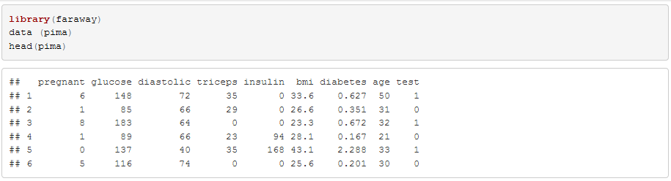

# Numerical Summaries

# Get the summary information for each metric.

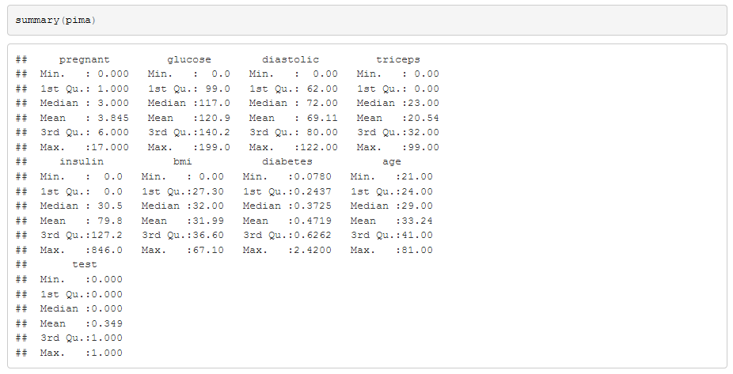

## **Value Ranges**

Look at the minimum and maximum values of each variable

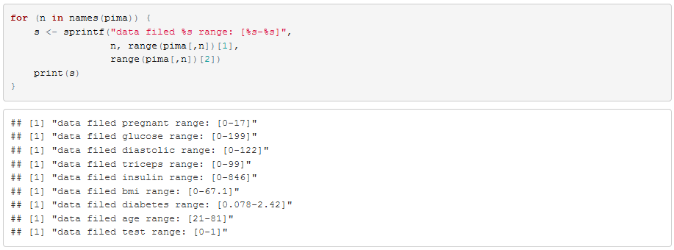

## **Clean Data**

## Normalize missing values in some variables:

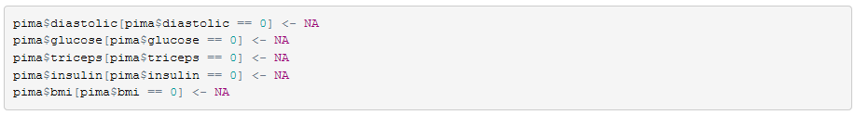

## Convert non-quantitative categorical variables to “factor”:

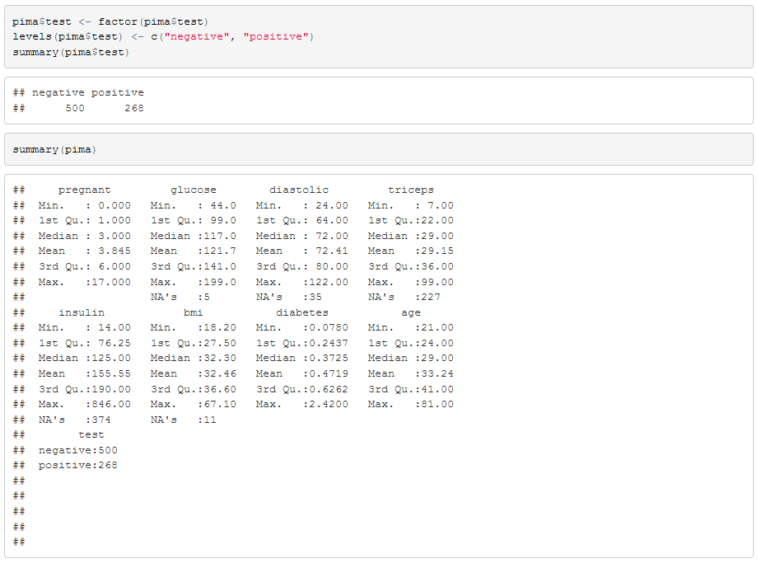

# Graphical Summaries

Get an overall look at single variables to see the distribution and possible outliers.

